NW Inventory OS Analysis App V1
Workflow and Data Flow Documentation
Document Type | Technical workflow and data flow reference
Application Version | V1
Primary Use Case | NW CMDB firmware validation and Inventory OS reconciliation
Output Option | Single Excel workbook with multiple analysis sheets
Prepared For | Official documentation, SOP, and transition reference
Purpose. This document explains the operational workflow and data flow of the NW Inventory OS Analysis App V1. It is written for official documentation so that users, support teams, and future developers can understand file intake, validation, matching logic, processing sequence, and output generation.

1. Scope of V1
V1 focuses on network operating system and firmware reconciliation between NW CMDB, Inventory OS, and Inventory OS Catalog data. Additional report upload slots are available in the GUI for future enhancements, but the V1 processing engine uses only the three required source files listed below.
File Slot | Required in V1 | Purpose | Processing Usage
Inventory Operating System | Yes | Provides Inventory hostname, parent serial number, and OS lifecycle status. | Used for hostname, serial number, and lifecycle checks.
NW CMDB Report | Yes | Provides Configuration Item, serial number, Firmware Version, and LifeCycle Stage. | Primary reconciliation baseline and firmware source.
Inventory OS Catalog Report | Yes | Provides software_product_name and Software Version. | Used to validate firmware catalog availability.
Inventory HW Catalog Report | No | Reserved for future hardware catalog analysis. | Loadable only in V1.
Server Baseline Report | No | Reserved for future server baseline checks. | Loadable only in V1.
Server Hardware Catalog | No | Reserved for future server hardware catalog analysis. | Loadable only in V1.
Network Hardware Catalog | No | Reserved for future network hardware catalog analysis. | Loadable only in V1.
Field Mapping File | Optional | Provides field mapping reference for documentation or future transformation logic. | Included as a reference sheet if loaded.

2. Workflow Diagram
The workflow diagram below shows the end-to-end user and processing sequence from opening the GUI through output workbook generation. It also shows the internal processing gates for required file validation, row metadata handling, flexible header resolution, firmware validation, Inventory OS matching, lifecycle comparison, and Excel workbook creation.
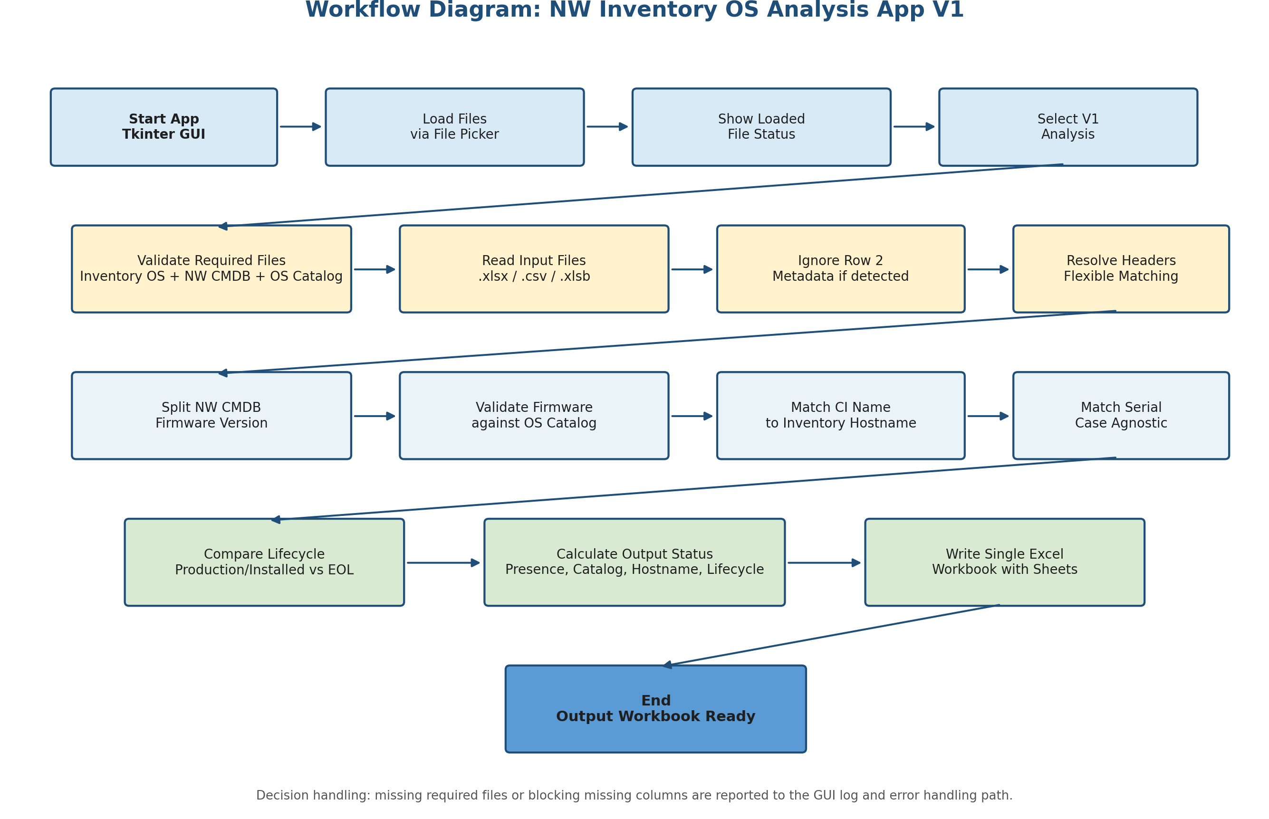
Figure 1. Workflow Diagram for NW Inventory OS Analysis App V1

3. Workflow Description
Step | Stage | Description | Expected Result
1 | Launch GUI | User opens the Tkinter-based application from VS Code or a Python runtime. | Main application window is displayed.
2 | Load files | User loads files through fixed file picker slots. The GUI shows loaded or not loaded status for each file. | Selected file paths are stored in memory.
3 | Select V1 analysis | The V1 analysis option is listed in the GUI and selected for execution. | Processing scope is confirmed as V1 reconciliation.
4 | Validate required files | The app checks that Inventory Operating System, NW CMDB Report, and Inventory OS Catalog Report are loaded. | Processing continues only when required files are present.
5 | Read and normalize data | The app reads .xlsx, .csv, or .xlsb files and standardizes text values. | Input data frames are prepared for analysis.
6 | Ignore metadata row | If Row 2 contains values such as Mandatory, Optional, Required, or Recommended, the row is excluded from calculations. | Only actual data rows are analyzed.
7 | Resolve headers | Header matching ignores case, spaces, hyphen, underscore, and dot differences. | Required logical fields are mapped to physical file columns.
8 | Run processing logic | Firmware split, catalog validation, hostname match, serial match, and lifecycle checks are completed. | Analysis columns and status values are calculated.
9 | Write output workbook | The app creates one Excel workbook with multiple sheets and formatted status columns. | Final workbook is saved to the user-selected folder.

4. Data Flow Diagram
The data flow diagram below shows how input reports pass through ingestion, normalization, matching, validation, and workbook generation. V1 uses three required reports for active processing. Other reports are accepted by the GUI to support a consistent future-ready interface.
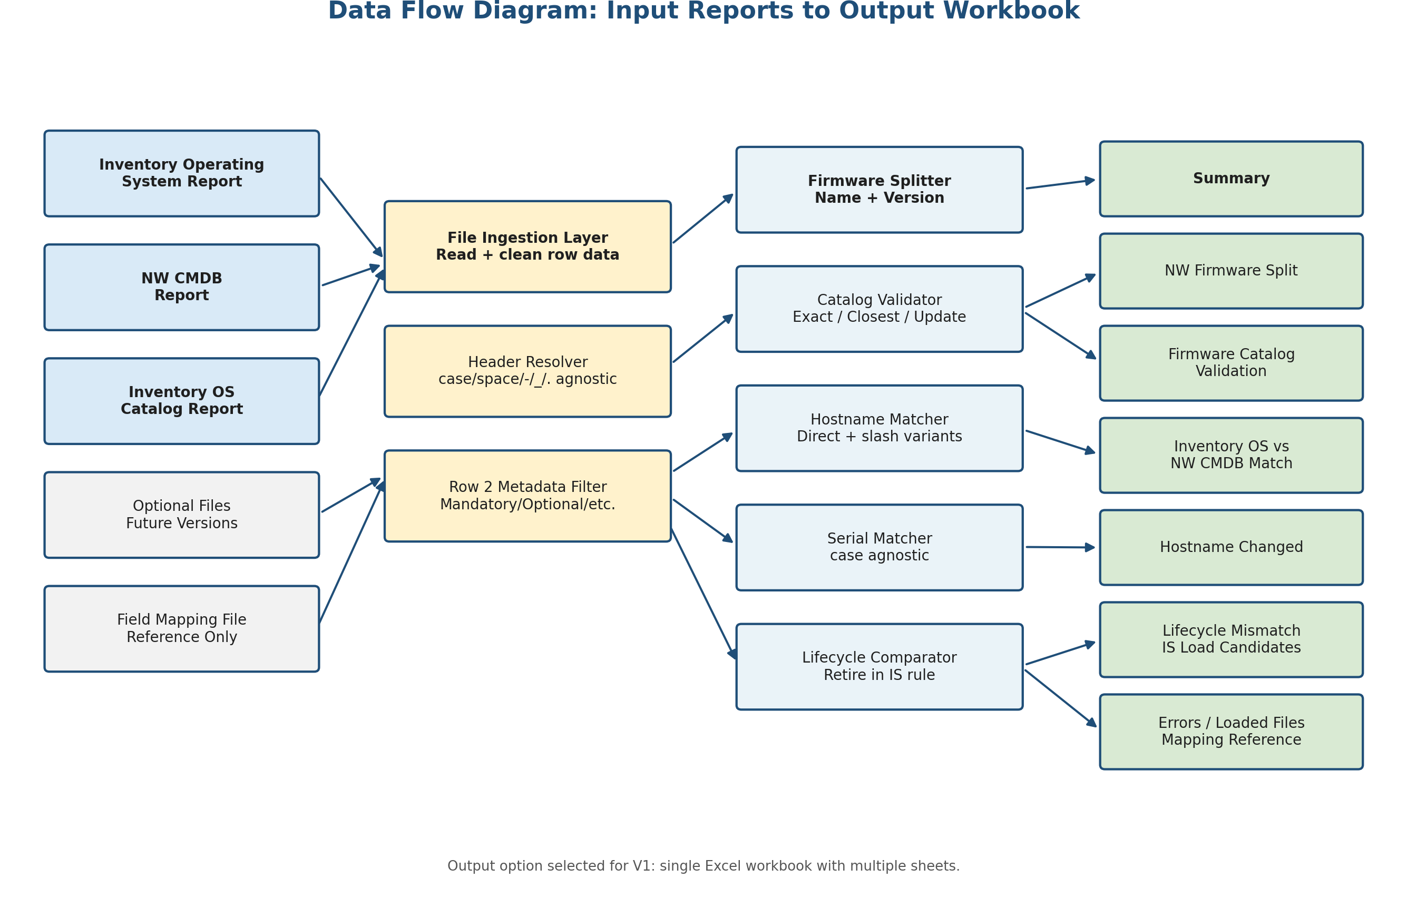
Figure 2. Data Flow Diagram for Input Reports and Output Workbook

5. Data Flow Description
Data Layer | Data Objects | Transformation / Processing | Output Contribution
Input Layer | Inventory Operating System, NW CMDB Report, Inventory OS Catalog Report | Files are read into internal tabular structures. Row 2 metadata is excluded where applicable. | Provides baseline records for reconciliation.
Header Resolution Layer | All input columns | Column names are matched using normalized forms that ignore case, spaces, hyphen, underscore, and dot differences. | Reduces dependency on exact header spelling variations.
Firmware Processing Layer | NW CMDB Firmware Version | Firmware source value is split into Firmware Name and Firmware Version using the last version-like token. | Feeds catalog validation and firmware split sheet.
Catalog Validation Layer | Firmware Name, Firmware Version, software_product_name, Software Version | Exact match and closest match rules are applied. Closest match allows trailing alphabetic suffix removal only. | Produces Match, Closest Match Proposed, or catalog update required.
Inventory Matching Layer | Configuration Item, Hostname, serial number, os_parent_serial_number | Direct hostname, CMDB slash replacement, and case-agnostic serial matching are performed. | Produces presence status and hostname changed indicators.
Lifecycle Layer | os_lifecycle_status and LifeCycle Stage | Inventory production/installed status is compared with CMDB End of Life stage. | Produces Retire in IS where applicable.
Output Layer | Calculated analysis frames | Analysis frames are written into a single formatted Excel workbook. | Creates Summary, validation, matching, exception, and reference sheets.

6. Core Matching and Validation Rules

6.1 Firmware Split Rule
The app reads the NW CMDB field named Firmware Version and splits it into Firmware Name and Firmware Version. The split is based on the last version-like token in the value. The original source value is preserved as Original Firmware Version in the output.
Original NW CMDB Firmware Version | Firmware Name | Firmware Version
Cisco IOS XE 17.12.07a | Cisco IOS XE | 17.12.07a
Cisco ASA 9.20(4)30 | Cisco ASA | 9.20(4)30
Cisco FXOS 2.14(3.124) | Cisco FXOS | 2.14(3.124)
Cisco AireOS 8.10.190.0 | Cisco AireOS | 8.10.190.0

6.2 Catalog Match Rule
Outcome | Rule | Business Meaning
Match | Firmware Name equals software_product_name and Firmware Version equals Software Version. | Firmware is already represented correctly in the OS catalog.
Closest Match Proposed | Product name matches and the version matches after removing only a trailing alphabetic suffix from the NW CMDB firmware version. | Catalog may already contain the base version and can be reviewed before update.
catalog update required | No exact or accepted closest match is found. | Catalog update or data correction may be required.

6.3 Inventory OS Reconciliation Rule
Check | Logic | Output Status / Indicator
Direct hostname match | NW CMDB Configuration Item is compared to Inventory OS Hostname. | Present in IS
Special character hostname match | If CMDB Configuration Item contains /, the app checks equivalent names where / is replaced by _ or -. | Present in IS -HostName with special character
Serial number match | NW CMDB serial number is compared to Inventory OS os_parent_serial_number using case-agnostic matching. | Matched by serial
Hostname changed | Serial number matches but hostname does not match directly or through slash replacement. | Hostname changed
Not found | No direct hostname, special hostname, or serial match is found. | Not Present in IS and listed under IS Load Candidates

6.4 Lifecycle Action Rule
The lifecycle rule identifies records where Inventory OS still shows an active state while CMDB identifies the CI as End of Life. The app marks these as Retire in IS.
Inventory OS os_lifecycle_status | NW CMDB LifeCycle Stage | Lifecycle Action
production or Installed | End of Life | Retire in IS
Blank or unavailable | Any value | Lifecycle data missing
Any other combination | Any other value | No lifecycle action

7. Output Workbook Structure
The V1 output option is a single Excel workbook with multiple sheets. Each sheet supports a specific operational or review activity.
Sheet Name | Purpose | Primary Audience
Summary | Provides total counts and key analysis metrics. | Service leads, governance team
NW Firmware Split | Shows NW CMDB records with firmware split into Firmware Name and Firmware Version. | CMDB and catalog analysts
Firmware Catalog Validation | Shows exact match, closest match, and catalog update required outcomes. | Catalog owners
Inventory OS vs NW CMDB Match | Main reconciliation sheet with hostname, serial, presence, catalog, and lifecycle statuses. | Inventory and CMDB analysts
Hostname Changed | Lists records where serial matched but hostname did not. | Data correction team
Lifecycle Mismatch | Lists records marked Retire in IS. | Lifecycle governance team
IS Load Candidates | Lists NW CMDB CIs not found in Inventory OS by hostname or serial matching. | Inventory Services load team
Missing Columns and Errors | Captures validation and processing issues. | Support and developer team
Loaded Files | Documents file paths and whether each file was used in V1 analysis. | Audit and support reference
Field Mapping Reference | Included only when a field mapping file is loaded. | Documentation and future transformation reference

8. Operational Notes and Controls
- Minimum V1 processing requires Inventory Operating System, NW CMDB Report, and Inventory OS Catalog Report.
- Other files are loadable in the GUI to keep the interface consistent for future feature expansion.
- Header matching is resilient to common naming variations, but the required logical fields must still be present in the input files.
- The app does not use fuzzy matching for firmware version comparison. Closest match is intentionally restricted to trailing alphabetic suffix handling.
- Context firewall hostname handling is based strictly on the CMDB Configuration Item value and slash replacement logic. The script does not infer parent firewall hierarchy.
- Serial number matching is case agnostic and blank serial numbers are ignored.
- All outputs are written to one Excel workbook selected by the user at runtime.

9. Exception Handling Summary
Exception Type | Application Behavior | User Action
Missing required file | Processing stops and the GUI shows an error. | Load the missing required file and rerun.
Missing required column | Processing stops because the core analysis cannot be completed reliably. | Confirm the source report contains the required field under an acceptable header variant.
Row 2 metadata detected | Row is ignored from calculation and analysis. | No action required unless actual data was placed in Row 2.
.xlsb dependency missing | The app shows guidance that pyxlsb is required. | Install pyxlsb or provide .xlsx/.csv input.
No catalog match | Record is marked catalog update required. | Review whether catalog update or source correction is needed.

End of Document

